

PPPM Strategic Plan

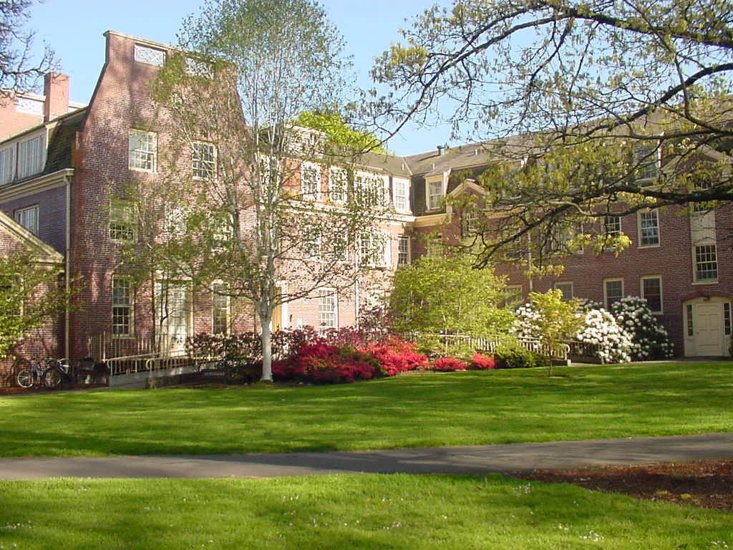

September 2021 Update

# Introduction

## School Background

Planning, Public Policy & Management (PPPM) was established in 1982 through the merger of the Wallace School of Community Service and Public Affairs (CSPA) and the Department of Urban and Regional Planning. The new PPPM Department was located in the School of Architecture and Allied Arts. In 2018, it became a School within the new College of Design.

The synergy created by bringing together faculty and students from planning and public affairs has been a vitalizing force for PPPM. Although faculty members are primarily identified with one program or the other, their backgrounds and interests are highly complementary. Students from both graduate programs, as well as the undergraduate program, are encouraged to take courses across the School's offerings and to make use of the entire faculty for academic and professional advice.

The School continues to develop and evolve. In 1994 the Resource Assistance for Rural Environments (RARE) program was established. In 1996 the name of the public affairs program was changed to public policy and management, to give more clarity to the program title. In 2001 the degree for the Public Policy & Management Program was changed from an M.A. or M.S. in Public Affairs to a Master of Public Administration (MPA). Also in 2001, the School was granted approval from the Oregon University System to offer a one-year graduate certificate program in Not-for-Profit Management. In 2011, the School launched its Master of Nonprofit Management (MNM) Program. In In 2020, the School launched a PhD in Planning and Public Affairs, which focuses on three core research areas: (1) Sustainable Transportation and Cities; (2) Access and Equity; and (3) Nonprofit, Philanthropic, and Social Enterprise.

In addition to its graduate programs, the School continues to offer an undergraduate non-accredited major in Planning, Public Policy and Management. The major is designed for upper division students with a broad social science background. Students must apply to the program, and there is a strong emphasis on experiential learning, internships and professional skills.

## Strategic Planning

The School’s overall direction is guided by a strategic plan. The first PPPM strategic plan was developed in 2006 and it is typically reviewed and updated at the School’s annual fall retreat. Specific elements such as curriculum, equity and inclusion, and hiring priorities have also been updated. The goal of this document is for it to be an active, working document that will guide faculty and School head decisions. While the broad vision and goals are ongoing, the School identifies several strategic actions each year on which to focus attention. Due to remote status and other pressing matters, the 2019-2021 reviews of this plan were limited and handled mostly through subcommittees.

# School Vision

The School of Planning, Public Policy and Management will be a national leader known for academic rigor, intellectual leadership, stellar evidence-based research, innovative applied instruction and its inclusive and equitable climate.

## Committed to Diversity, Equity, and Inclusion

Since 2015, we have been actively working to address diversity, equity, and inclusion in the School of PPPM. This joint faculty and student effort has been called the PPPM Equity Initiative. Although we have made progress, there is further need to address these issues for all members of the PPPM community. As a community, we commit to holding each other accountable to these standards of diversity, equity, and inclusion.

We also recognize that a host of related national conversations and events have taught us that to accomplish this we need to center on the role that race/ethnicity plays in adversely affecting students, faculty, staff, and alumni. We join other institutions who are figuring out in the moment what leading by race means. There is building consensus that advancing equity requires us to focus specifically on race/ethnicity as we strive to address all areas of marginalization and further our awareness on the intersectionality of various forms of oppression. It is in this spirit that we have updated what PPPM means by diversity, equity, and inclusion. We also provide links to past, current, and ongoing actions taken by our school to advance equity. Our work here is not static but evolving in response to continual dialogue and feedback.

### Diversity Action Planning in PPPM

The Equity Initiative leads PPPM’s efforts to implement actions, strategies, and policies related to equity and diversity. These efforts are linked to Diversity Action Planning (DAP) coordinated by the College of Design and the University of Oregon's Division of Equity and Inclusion. You can find more details about PPPM's efforts on our [PPPM Equity Initiative](https://blogs.uoregon.edu/pppm/equity-and-inclusion/) webpage.

## Defining Our Principles

### Diversity

PPPM foregrounds racial and ethnic identities that have been historically excluded or have experienced substandard access to resources to meet their educational aspirations and potential in our public service fields. This includes all Indigenous peoples and individuals from the various Black, Latina/o/x, and Asian diasporas. Our centering of racial and ethnic identities does not contest or exclude the various other identities of groups that also experience marginalization and structural challenges in higher education, including gender, sexual orientation, ability, and lower socioeconomic background. PPPM must also be accountable to these and other under-represented identities in higher education. Yet, the targeting of our approach by race/ethnicity as they intersect with other marginalized identities is aimed to address acute and sustained disadvantages.

### Equity

PPPM commits to centering racial and ethnic equity when allocating resources. Our resources should support the development of initiatives, programs, and support systems that aim to address, reverse, and change the social, political, and economic structures of inequality. An equity lens filters all the organizational decisions we make regarding curriculum development, faculty and staff hires, student recruitment, retention and support, and PPPM’s development and growth.

### Inclusion

Our aim is to create an school environment where the initiatives, programs, research, and support systems we develop are geared toward addressing the nuanced and complex needs of our community members internally and those we work with who are Indigenous and of the various Black, Latina/o/x, and Asian diasporas, in addition to others whose identities are marginalized in higher education. In so doing, we strive to support and empower their voices, ambitions, and whole-person development.

## Mission Statement: Public Administration

The purpose of the Master of Public Administration (MPA) program at the University of Oregon is to promote evidence-based decision making and the efficient and ethical stewardship of societal and environmental resources by professionals in the public and nonprofit sectors. We support this purpose by training a diverse cohort of students from the US and abroad to be effective administrators, analysts and advocates in their communities. The MPA provides a curriculum that values students who are committed to public service, offering a close connection between multi-disciplinary policy-oriented research and opportunities for real world applications. Students are supported in creating a customized course plan that allows for the most effective use of their time as full-time or part-time students. Our program combines a rigorous academic approach in the development of analytical and managerial skills with highly experiential opportunities such as the 48-hour policy project and a client centered capstone research project.

## Mission Statement: Community and Regional Planning

The Community and Regional Planning program prepares innovative public leaders through a challenging, applied curriculum and inclusive and equitable climate. Program faculty and students creates and disseminates new knowledge, and engages in intensive partnerships to solve society's most pressing economic, environmental and social issues.

## Mission Statement: Nonprofit Management

The Master of Nonprofit Management program at the University of Oregon fosters nonprofit executive leadership for the rapidly evolving nonprofit/NGO sector. We believe that the most effective nonprofit management requires a practical, experiential education that teaches vital skills and allows students to practice those skills in administrative service to regional organizations. To best prepare future nonprofit executives, we provide a rigorous curriculum tailored to meet the distinct needs of nonprofit and philanthropic organizations.

## Learning Objective: Undergraduate Major

The objective of the Bachelor's Degree Program in Planning, Public Policy & Management is to provide students with a broad professional background as well as a sound basis for graduate study in fields such as planning, public policy and management, business, law, journalism, and social welfare. In addition, graduates are prepared for entry-level positions in a variety of public service agencies and organizations.

# Research Groups

In 2017, PPPM faculty held a series of workshops to identify research clusters. This process identified three existing strengths that would be the basis for our PhD program:

* [Access and Equity](https://pppm.uoregon.edu/research-areas/access-and-equity)
* [Nonprofit, Philanthropic, and Social Enterprise](https://pppm.uoregon.edu/research-areas/nonprofit-management-philanthropy)
* [Sustainable Transportation and Cities](https://pppm.uoregon.edu/research-areas/sustainable-transportation-and-cities)

As a result of these efforts, PPPM was awarded three new faculty positions in two key areas: (1) Access and Equity; and (2) Sustainable Transportation and Cities. The new faculty joined PPPM in Fall 2019 and the PhD program was launched in Fall 2020.

# Other Research Areas

PPPM faculty address some of the most critical issues facing our society today. The areas listed below involve several faculty members in PPPM as well as other faculty across the university.

* [Urbanism Next](https://pppm.uoregon.edu/research-areas/urbanism-next)
* [Public Engagement](https://pppm.uoregon.edu/research-areas/public-engagement)
* [Housing Policy and Affordability](https://pppm.uoregon.edu/research-areas/housing-policy-and-affordability)
* [Resilience and Natural Hazards](https://pppm.uoregon.edu/research-areas/resilience-natural-hazards)
* [Immigration and Trans-Border Organizations](https://pppm.uoregon.edu/research-areas/immigration-trans-border-organizations)
* [Science, Technology, and Economic Development Policy](https://pppm.uoregon.edu/research-areas/science-technology-economic-development-policy)
* [Environment and Resilience](https://pppm.uoregon.edu/research-areas/environment-resilience)
* [Arts and Cultural Policy and Leadership](https://pppm.uoregon.edu/research-areas/arts-cultural-policy-leadership)
* [Land Use and Growth Management](https://pppm.uoregon.edu/research-areas/land-use-growth-management)
* [Community Health and Well Being](https://pppm.uoregon.edu/research-areas/community-health-well-being)

Faculty also conduct research in other areas independently (see [faculty profiles](https://pppm.uoregon.edu/faculty-and-staff)).

## Institutes and Centers

PPPM is the home of the [Institute for Policy Research and Engagement](https://ipre.uoregon.edu/) IPRE has collaborated with partners across the state while involving faculty and students in substantive projects in such areas as community engagement, community resilience, economic development, entrepreneurship and business development, food systems, housing, land use, natural hazards, natural resources management, nonprofit management, and program and policy evaluation. The School of Planning, Public Policy and Management has strong affiliation with

[Sustainable Cities Institute](https://sci.uoregon.edu/)

[National Institute for Transportation and Communities (NITC)](http://nitc.trec.pdx.edu/)

[Institute for a Sustainable Environment (ISE)](http://sustainable.uoregon.edu/)

## Key Goals and Objectives

The PPPM School will pursue a range of high priority strategies to support the School Vision. These strategies will be used to guide policy, resources, and partnership efforts. The PPPM School will pursue a range of high priority strategies to support the School Vision. These strategies will be used to guide School policy, resources and time, and be used to solicit UO and external partnerships.

### Goals and Objectives

### A. Foster Rigorous Academic Programs

1. Increase the number of graduate fellowships and assistantships
2. Increase support for undergraduate students
3. Increase visibility of programs through publicity and outreach
4. Support and facilitate concurrent degree opportunities across campus
5. Improve the quality of instruction through PPPM sponsored teaching seminars, awards and other initiatives
6. Increase the diversity of graduate enrollment to ensure a learning environment that reflects the diversity of communities that our graduates serve
7. Enhance the curriculum to better addresses issues of diversity, equity and inclusion
8. Promote resources, training and workshops to improve the ability of instructors to address issues of bias, diversity, equity and inclusion
9. Continue to grow the three grad and undergrad programs commensurate with resources
10. Recruit and retain high quality students across both grad and UG program
11. Increase number of tenure track faculty and career non-tenure track faculty
12. Increase diversity of applicants for tenure track faculty and career non-tenure track faculty

### B. Achieve National Level Intellectual Leadership

1. Continue to support public leadership efforts through the Community Service Center and the Sustainable Cities Initiative
2. Provide forums for deliberating and discussing important public issues in Eugene-Springfield, Salem, Portland and other locations
3. Increase public and professional visibility of faculty research, leadership and student work

### C. Develop Stellar, Evidence-Based Research

1. Fund exploratory research led by PPPM faculty that will increase external funding possibilities
2. Promote collaboration, collegial support of scholarship, and constructive criticism that will lead to improved research

### D. Become Nationally Known for Innovative Applied Instruction

1. Strengthen the relationship with the Community Service Center to provide critical applied learning opportunities
2. Expand the 48-hour and Capstone programs into new substantive areas and new clients
3. Develop new partnership and funding opportunities for the Nonprofit Masters program
4. Support the partnership with the Sustainable Cities Initiative, including opportunities for interdisciplinary courses and forums
5. Promote and encourage applied instruction across the full range of PPPM course work

### E. Create a School Climate that is inclusive, equitable and supportive for learning

1. Maintain an Equity and Inclusion Initiative composed of faculty and students to coordinate monitoring, events, strategies and actions
2. Ensure an inclusive, equitable and safe environment for all students to learn, work and conduct research
3. Ensure students have input into School matters and can safely voice concerns
4. Enhance the undergrad community
5. Improve facilities to ensure high quality space for teaching, learning and research

# Action Plan—2021-2022 Update

|  |  |
| --- | --- |
| Goals and Objectives | Strategic Actions (New or Ongoing) |
| A. Foster Rigorous Academic Programs | |
| 1. Increase visibility of programs through publicity and outreach | * Produce IPRE Report for UO Administrators and External Partners (Lead: Lewis; completed Fall 2021) * Increased partnerships through IPRE (ongoing) * Publicize/Research Effectiveness of CWP (Lead: Margerum; completed Spring 2022—Article accepted in JPER) |
| 1. Support and facilitate concurrent degree opportunities across campus | * No actions planned this year |
| 1. Improve the quality of instruction through PPPM sponsored teaching seminars, awards and other initiatives | * PPPM/IPRE Seminar Series in 2021-22 (Lead: Redaelli) |
| 1. Increase the diversity of graduate enrollment to ensure a learning environment that reflects the diversity of communities that our graduates serve | * Continue to use tuition fee reduction to increase student quality and diversity (Graduate Program Heads) |
| 1. Enhance the curriculum to better addresses issues of diversity, equity and inclusion | * Review and update to MNM Curriculum in Fall 2021 (Lead: Mason) * New courses under development or being added: PPPM 321: Inclusive Urbanism (Lead: Arroyo) PPPM 101: Advocacy and Social Change (Lead: Mason) |
| 1. Promote resources, training and workshops to improve the ability of instructors to address issues of bias, diversity, equity and inclusion | * Fall retreat discussion about cross cutting program learning objectives and undergraduate enrollment (Lead: Margerum) * Teaching and Training Workshops (Lead: Teaching and Learning Committee)   + Winter workshop on mental health   + Spring workshop TBA |
| 1. Continue to grow the three grad and undergrad programs commensurate with resources | * ONGOING |
| 1. Recruit and retain high quality students across both grad and UG program | * Track reasons for coming / not coming to UO (Lead: Bob C) * Review and assess social media outreach and work with College to increase social media (Lead: Tash O’Brien; Communications Comm)🡪 New student employee hired to coordinate social media * New process for tracking leaves and encouraging re-enrollment (Lead: Bob C.) |
| B. Achieve National Level Intellectual Leadership | |
| 1. Continue to support public leadership efforts through IPRE and SCI | * Ongoing |
| 1. Provide forums for deliberating and discussing important public issues | * No major actions planned this year * IPRE team presentations to the Oregon Higher Education Commission (Lead: Clark; Spring 2022) |
| 1. Increase public visibility of faculty research, leadership and student work | * Support public and campus events to increase visibility---implemented through PPPM/IPRE Research Seminar Series (Lead: Redaelli) |
| C. Develop Stellar, Evidence-Based Research | |
| 1. Fund exploratory research that will increase external funding possibilities | * Annual Kvarsten grant--approx. $4500 (Lead: Margerum) |
| 1. Promote collaboration, collegial support of scholarship, and constructive criticism that will lead to improved research | * IPRE/Research groups meetings to discuss collaboration opportunities (Leads: Lewis and Clark) * Transportation and Sustainable Cities Research Group: sponsors regular research events and speakers (Lead: Schlossberg; ongoing 2021-22) * Access and Equity Research Group: limited events mostly through existing campus networks and Mellon Foundation Grant (ongoing 2021-22) * Nonprofit and Philanthropy Research Group (on hold for 2021-22 due to limited capacity) |
| D. Become Nationally Known for Innovative Applied Instruction | |
| 1. Strengthen the relationship with IPRE to provide critical applied learning opportunities | * Identify potential awards and competitions (Lead: Clark and Lewis) * Seek publicity through UO Communications (Lead: Lewis and Margerum) |
| 1. Develop partnerships & funding for Nonprofit Masters program | * Ongoing—No specific actions planned |
| 1. Support partnership with Sustainable Cities Initiative | * Ongoing—No specific actions planned |
| 1. Promote and encourage applied instruction across all PPPM course work | * Ongoing—No specific actions planned |
| E. Create a School Climate that is inclusive, equitable and supportive for learning | |
| 1. Maintain an Equity and Inclusion Initiative composed of faculty and students to coordinate monitoring, events, strategies and actions | * Ongoing (Lead: Margerum)—see actions listed below |
| 1. Ensure an inclusive, equitable and safe environment for all students to learn, work and conduct research | * PRIORITY: led by E&I initiative   + Affinity groups for BIPOC and LGBTQ students   + Events to promote community building (Winter and Spring terms)   + Winter term listening session   + Spring term panel on Nonprofits and Racism |
| 1. Ensure students have input into School matters and can safely voice concerns | * Student Advisory Board: includes undergraduate and graduate representation to improve communication between students and faculty * Meets twice per term |
| 1. Enhance the undergrad community | * Encourage UG participation in student groups (Lead: Matthiesen) * Support outreach and community building efforts (Lead: Student Community Organization) |