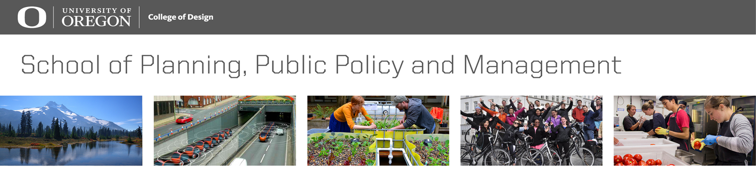 | Graduate Professional  Development  Plan (PD Plan)  Note: Please type this plan.

Student Name: _____________________________________________________________Date of PD Plan update: _____________________

The Professional Development Plan assignment is intended to help you with career management skills including:
- Understand and navigate the evolving employment landscape
- Conduct a purposeful career search
- Plan specific activities over the course of your degree program in PPPM that can help you attain the type of job you want upon degree completion
- Develop skills and habits necessary for lifelong career management
Part 1. Describe your career goals (use this or another page to write your thoughts)
- First consider these types of questions: What sector(s) of the economy or creative life (public, for-profit, nonprofit, entrepreneurial; federal, state, local government) appeal to you? What size/type(s) of organizations appeal to you most? What size and type of community (rural, urban, healthcare or education center, other) can you see yourself living in? What geographic locations would you like to live in (or not)?

- It’s important to consider and set boundaries and parameters about where you don’t you want to be as well as where you are striving to go. Describe here geographic, work environment, work sectors, or other boundaries regarding what you want to avoid or that do not help you thrive or find joy:

- What values do you cherish the most in your professional life (e.g. financial success, innovation, creativity, community, teaching, growth, peace, authenticity, empowering others, fairness, equity, leading and embracing change, inspiring others, etc.)? What values do you more readily discard?

- What skills (e.g. time management, verbal communication, report writing…) and strengths (e.g., driver, motivator, relator, maximizer…) do you possess that you want to build on further or that provide you the most joy and satisfaction? What skills/strengths do you want to deemphasize?

- Given your responses to the above, what are your short-term career goals (e.g. 6 mo – 1 year post graduation)? What types of employment positions fit your short-term career goals? Describe your timeline for achieving them.

- Given your responses to the above, what are your long-term career goals (5-10 years post-graduation)? What types of employment positions fit your long-term career goals? Describe your timeline for achieving them.

- When do you anticipate beginning a job search? If you have already begun a search, briefly describe.

Part 2. Identify required and preferred qualifications for your ideal jobs.
- Find at least one job or fellowship database that interests you on the PPPM Finding Opportunities webpage.
- Use the database(s) you selected to identify 3 jobs or fellowships you would like to pursue immediately following graduation. Review descriptions for these positions.
- Type the name of the organizations and job/fellowship titles in the first column of the chart below (add more space as needed).
- List the top 3 required competencies or qualifications and the top 3 preferred competencies or qualifications (if stated) for each job or fellowship in the designated righthand columns. List any competencies or qualifications that were unanticipated or surprised you in the third column. Add more rows or columns as needed (e.g. this is one format -- make this format work for you and how you think and visualize!)
- Review the competencies/qualification lists you just created. Identify gaps in your own knowledge, skills, and experience to date. Examples may include competencies in areas such as:
  - discipline specific conceptual knowledge (theories/concepts, methods, tools);
  - research skills (methods of measurement, experiment design, analytical techniques, peer review processes);
  - communications (technical/other writing styles, resume & cover letter writing, portfolio development, visual & oral presentations, teaching, job interviews & networking);
  - professionalism (interpersonal relationships, multicultural understanding and relationship building, institutional obligations, public service, allyship)
  - leadership and management skills (staff/project & time management, , budget preparation, strategic planning, mentoring/role modeling, meeting facilitation, delegation)
  - responsible conduct (data sharing & ownership, authorship, human subjects/other research approvals, scientific, moral/ethical misconduct, reporting, conflicts of interest)
- Review the items you wrote in columns 2-4. Highlight the key competencies/qualifications in your chart that are currently gaps for you and that you will seek to develop during your graduate program to be competitive for the post-degree jobs or fellowships you identified.

 | Top 3 Required Technical & Human Qualifications/Competencies - Knowledge, Skills, Experience | Top 3 Preferred Technical & Human Qualifications/Competencies - Knowledge, Skills, Experience | Unanticipated Qualifications/Competencies - Knowledge, Skills, Experiences – Or what would you like to know more about?
[Organization 1 - Job/Fellowship Title 1]
[Organization 2 - Job/Fellowship Title 2]
[Organization 3 - Job/Fellowship Title 3]

Part 3. Your Plan for Acquiring Additional Knowledge, Skills, & Experience
- Based on the competencies and qualifications you highlighted in Part 2 above, use column 1 below to list at least 3 of the competencies or qualifications you seek to develop prior to the completion of your degree. Add more rows as needed.
- In the second column below, list the approaches you will use to gain the desired knowledge, skills, and experience. Consider course work, volunteer experience, internships (both credit and noncredit), research or client projects, work study, serving on a board or commission, Capstone, CPW, Nonprofit Consultancy, Toastmasters or other professional development opportunities.
- In the third column list the projected timeline to develop your competencies and qualifications. For example, if you want to develop your public speaking skills, you could join UO Toastmasters and project Spring 20xx as your timeline.

Qualifications to be Developed  Knowledge, Skills, & Experience | Approaches to Gain Knowledge, Skills & Experience (e.g. What kinds of classes or co-curricular activities could help you develop the skills these roles require?) | Types of Target Organizations or Agencies with this roles or occupations? | Timeline (list term/year) for accomplishing gaining this competency and How does this change or reinforce your career aspirations?

Note that this Professional Development Guide is one method to develop a comprehensive and structured self-assessment in order to find your ideal job. It builds upon the steps identified in this chart from MyCareerMapping.com. Please use the above tool for PPPM 623. You can modify the tool to more visually/textually represent how you think about these topics and share your findings as well. For future work, you may want to use or adapt other tools that assist your own approach and structure for thinking about your future professional roles and career opportunities.

